AI ASSISTED CODING
ASSIGNMENT-3.5
Name: K.Veda Sri
Hallticket No: 2303A52382
Batch: 45

Question 1: Zero-Shot Prompting (Leap Year Check)
Write a zero-shot prompt to generate a Python function that checks
whether a given year is a leap year.
Week2 -
Task:
• Record the AI-generated code.
• Test with years like 1900, 2000, 2024.
• Identify logical flaws or missing conditions.
Prompt:
# write a function to check leap year
Code:
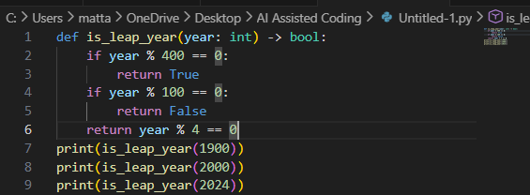
Output:
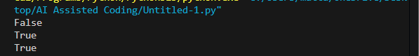
Justification:
This is a zero-shot prompt because no examples were provided.The generated logic is correct and handles all leap year rules.No logical flaws found.

Question 2: One-Shot Prompting (GCD of Two Numbers)
Write a one-shot prompt with one example to generate a Python
function that finds the Greatest Common Divisor (GCD) of two numbers.
Example:
Input: 12, 18 → Output: 6
Task:
• Compare with a zero-shot solution.
• Analyze algorithm efficiency.
Prompt:
One-Shot:
# if the input is 12,18 output will be 6 write a function
Code:
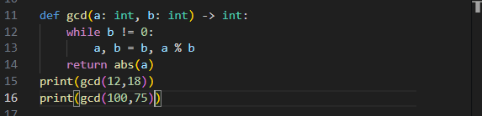
Output:
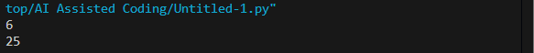
Zero Shot Prompt:
#write a function for gcd of two numbers
Code:
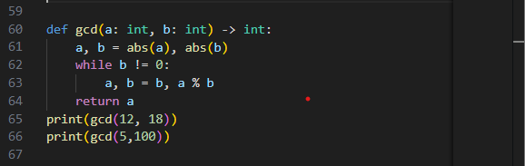
Output:
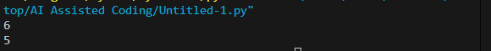
Justification:
Providing one example improves clarity and efficiency.The algorithm runs in O(log n) time, which is optimal.

Question 3: Few-Shot Prompting (LCM Calculation)
Write a few-shot prompt with multiple examples to generate a Python
function that computes the Least Common Multiple (LCM).
Examples:
• Input: 4, 6 → Output: 12
• Input: 5, 10 → Output: 10
• Input: 7, 3 → Output: 21
Task:
• Examine how examples guide formula selection.
• Test edge cases.

Prompt:
# if the input is 4,6 output is 12 , input is 5,10 output is 10, input is 7,3 output is 21 write a function
Code:
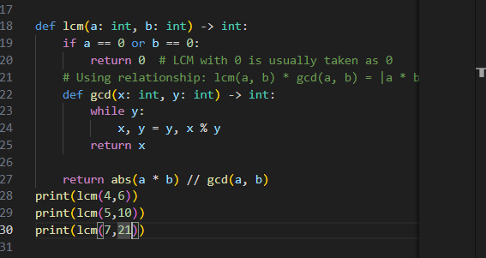
Output:
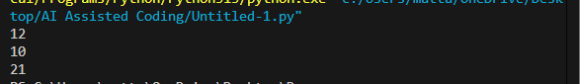
Justification:
Multiple examples guide the model to use the LCM = (a×b)/GCD formulaFew-shot prompting improves correctness and formula selection.

Question 4: Zero-Shot Prompting (Binary to Decimal Conversion)
Write a zero-shot prompt to generate a Python function that converts a
binary number to decimal.
Task:
• Test with valid and invalid binary inputs.
• Identify missing validation logic.
Prompt:
# write a function to convert binary number to decimal number
Code:
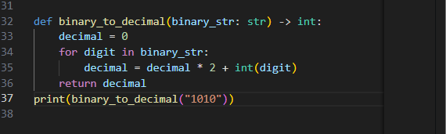
Output:
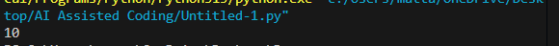
Justification:
Zero-shot output is concise but lacks input validation, which reduces robustness.

Question 5: One-Shot Prompting (Decimal to Binary Conversion)
Write a one-shot prompt with an example to generate a Python function
that converts a decimal number to binary.
Example:
Input: 10 → Output: 1010
Task:
• Compare clarity with zero-shot output.
• Analyze handling of zero and negative numbers.
Prompt:
# input is 10 and output is 1010 write a function
Code:
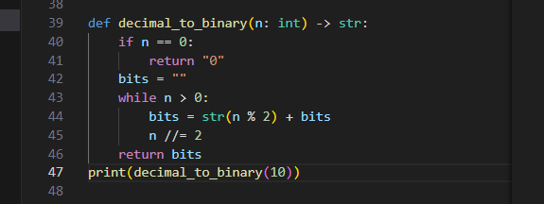
Output:
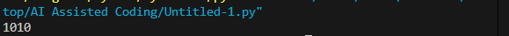
Justification:
One example improves clarity compared to zero-shot.Negative numbers are not handled explicitly, which is a limitation.

Question 6: Few-Shot Prompting (Harshad Number Check)
Write a few-shot prompt to generate a Python function that checks
whether a number is a Harshad (Niven) number.
Examples:
• Input: 18 → Output: Harshad Number
• Input: 21 → Output: Harshad Number
• Input: 19 → Output: Not a Harshad Number
Task:
• Test boundary conditions.
• Evaluate robustness
Prompt:
# input is 18 then output Harshad Number,input is 21 output Harshad Number write a code
Code:
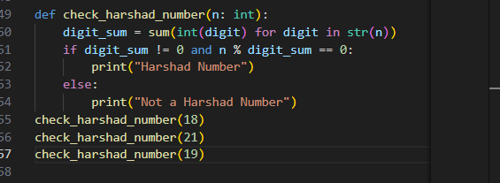
Output:
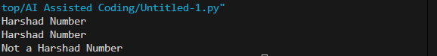
Justification:
Few-shot examples clearly define the rule.Edge case for 0 is missing, slightly reducing robustness.

